Batch: B2 Roll No.: 16010121200
Experiment No. 03

Title: Installation and study of QGIS

Objective:
Gain a basic understanding of what a GIS is and know open-source GIS software-QGIS

Expected Outcome of Experiment:

CO | Outcome
CO3 | Apply software processing techniques to prepare statistical modelling for geospatial healthcare and text data.

Books/ Journals/ Websites referred:
https://qgis.org/en/site/forusers/download.html
What is GIS?
A geographic information system (GIS) is a system designed to capture, store, manipulate, analyse, manage, and present all types of geographical data.
Free and open-source GIS:
- OSGeo


- GRASS GIS


- mapfish


- Quantum GIS

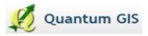
- GeoServer


Vector data:
Vector data represents geographic data symbolized as points, lines, or polygons.
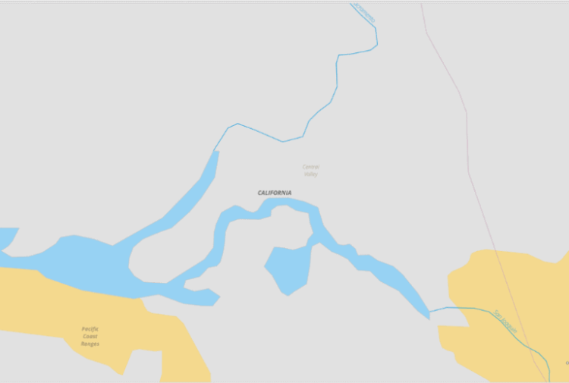
Raster Data:
Grid of pixels containing images or data.
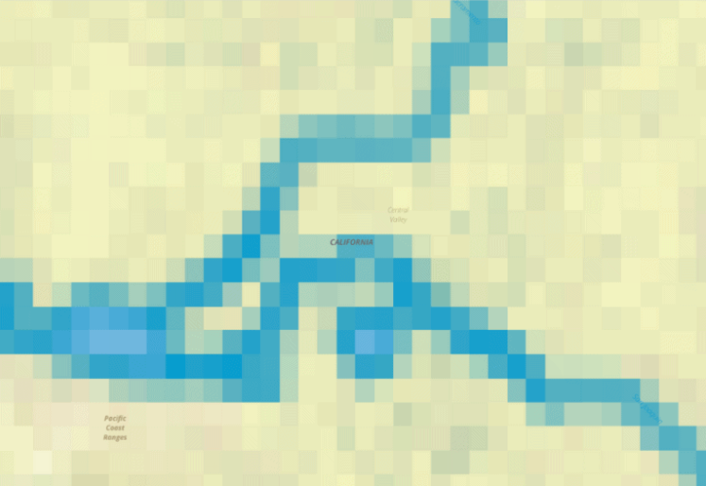
Network Data:
A Network dataset is a GIS dataset that is designed to support network analysis. It typically consists of lines representing the routes of flow in the network, augmented with other features (such as junction points), topology, and attributes that model network-relevant properties such as impedance and capacity of flow.
Data formats:
- Vector data
- Shapefiles – shp
- Geojson – json
- Geopackage – GPKG
- GPS Data – GPX
- Google Map Data – KML / KMZ (zipped)
- Data in Excel sheet – CSV
- GeoDataBase – GDB
- Drawing from AutoCAD/arccard – dwg
- Openstreetmap - .osm
- Comma Separated Values - .csv

- Raster data:
- Portable Network Graphics - .png
- Joint Photographic Expert Group - .jpeg
- Enhanced Compressed Wavelet - .ecw
- Tagged Image File Formats - .tiff
- Geo Tagged Image File Formats - .geotiff
- Digital Elevation Model - .ddf
- Portable Document Format - .pdf
Projections and coordinate systems:
Map projections are sets of mathematical models which transform spherical coordinates (such as latitude and longitude) to planar coordinates (x and y). In the process, data which actually lie on a sphere are projected onto a flat plane or a surface. That surface can be converted to a planar section without stretching.
Once map data is projected onto a planar surface, features must be referenced by a planar coordinate system. The geographic system (latitude-longitude), which is based on angles measured on a sphere, is not valid for measurements on a plane. Therefore, a Cartesian coordinate system is used, where the origin (0, 0) is toward the lower left of the planar section. The true origin point (0, 0) may or may not be in the proximity of the map data in use.
What is QGIS?
QGIS is a free and open-source cross-platform desktop geographic information system (GIS) application that supports viewing, editing, printing, and analysis of geospatial data.
Installation steps of QGIS:
- Navigate to the QGIS download page.

https://qgis.org/en/site/forusers/download.html
- Find appropriate installer for operating system.
- Run the installer when it has finished downloading.

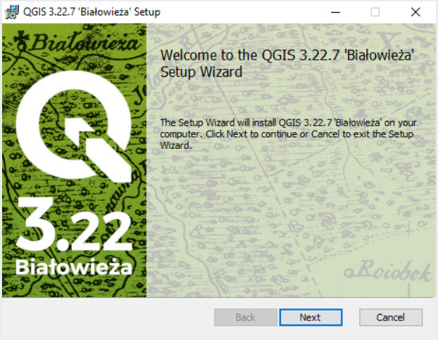
- Continue installation using default installation options.
- QGIS should now be installed.
Key components of QGIS:
- MENU BAR provides access to all the main functions and plugins.
- TOOLBAR provides one-click common functions, and task-speciﬁc functions.
- ADD DATA along the left side is the default location for the Manage Layers Toolbar.
- LAYER LIST shows all data layers currently added to the project.
- FILE BROWSER browse to geodata ﬁles and drag them onto the map canvas to open them.
- MAP VIEW provides a dynamic visualization of the active data layers that can be mapped.
- STATUS BAR provides some vital information about the current project settings.
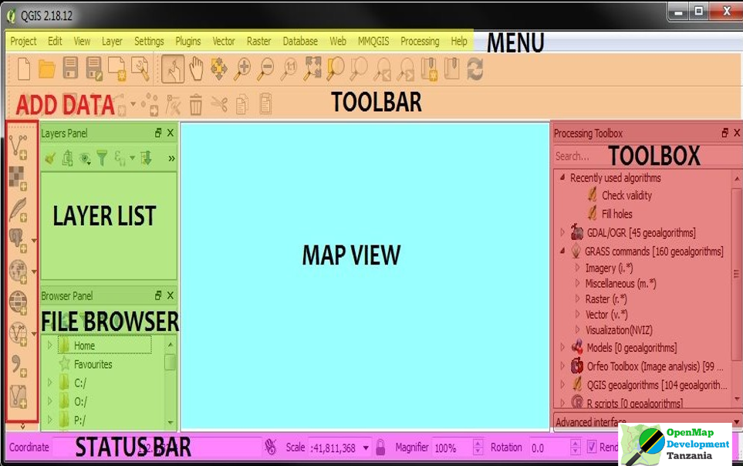

Explain how to set up a project and save work and what some of the most useful buttons do.
- PROJECT menu is for Opening, Saving, setting Project Properties (such as CRS), launching Print Composer, or saving quick image of map view
- EDIT menu is for adding, modifying, deleting spatial features within an editable data layer
- VIEW menu is for primary Pan, Zoom, Feature Selection, and Toolbar Controls
- LAYER menu is for Adding, Removing, Visibility of data layers, and for changing Layer Projections
- SETTINGS menu controls the basic Project settings, Project projection, Language Locale, & other defaults
- PLUGINS menu lists the installed Plugins where you can Add or Remove Plugins
- VECTOR menu contains Table Manager, Topology Checker, and other useful tools (NOTE: Most of the geoprocessing functions, like Buffer, Point in Polygon, Select by Location, etc have MOVED to the Processing menu)
- RASTER menu is for Raster processing functions, such as Heatmap and Zonal Stats (more are enabled with GRASS)
- DATABASE menu provides basic import / export operations for databases that have ALREADY been connected using the Manage Layers Add Database buttons.
- WEB menu contains the OpenLayers Plugin, where many basemaps can be added (including OSM, Google, Bing, etc), and also has the TileLayer Plugin
- PROCESSING menu contains the TOOLBOX for running many geoprocessing tasks, the Model Builder for chaining tasks, and controls the additional scripts that can be run in QGIS such as Grass, Python, R, SAGA, etc.
Downloading and loading data:
A vital skill for using GIS skills to solve real-world problems is finding, downloading, and importing data.
- Downloading data (map):
- Create Map using Map Marker - https://www.mapmarker.app/webapp/#/
- Create a vector map using polygons, lines, points
- Export created map as KML or KMZ.
- Importing data (map):
- Open QGIS
- Go to Layer → Add Layer → Add Vector Layer (alternatively press Ctrl + Shift + V)
- Under source, browse to the exported KMZ file.
- Click on Add → Select All → Add Layers
- The KMZ file is imported into QGIS

Style and select features:
- Labelling shape file:
- Go to the menu item View ‣ Toolbars.
- Ensure that the Label item has a check mark next to it. If it doesn't, click on the Label item, and it will be activated.
- Click on the places layer in the Layers list, so that it is highlighted.
- Right-click on the selected layer to open properties of the layer.
- Click labels on the left panel.

- Give colours to various polygons/lines/points in shape file:
- Click on the places layer in the Layers list, so that it is highlighted.
- Right-click on the selected layer to open properties of the layer.
- Click symbology on the left panel.

- Saving style made so it can be used for later need. (.sld)

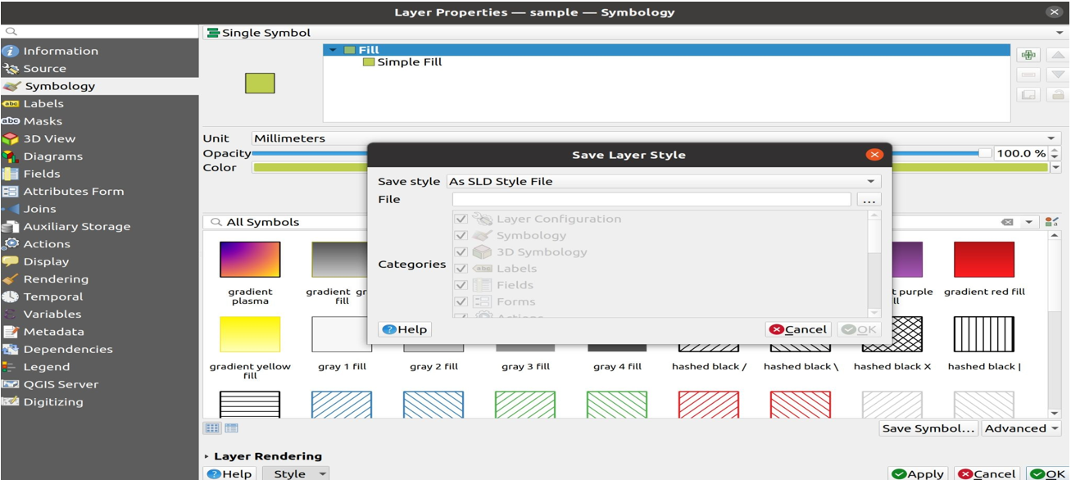

Post-lab questions:
Comment on your experience with working of QGIS.
QGIS is easy to learn and use. GUI is excellent. Very helpful to analyse map data in either vector or raster form. The software is also free and open-source, making it easily accessible to anybody.
Conclusion:
Explored the QGIS software and its features. Understood the use of GIS in everyday life and its applications in real time. Explored sites like Map Marker, to create vector maps, to import into QGIS for further analysis.

